Elite Proxy
# Source: Chatgpt (GPT‑5 Mini) at [1/14/2026]
An Elite Proxy (also known as a High Anonymity Proxy) is the most private and secure type of proxy that completely hides the fact that you are using a proxy.

🔐 Definition:
# Source: Chatgpt (GPT‑5 Mini) at [1/14/2026]
An Elite Proxy:
- Hides your real IP address
- Does not reveal itself as a proxy
- Makes your requests appear as if they are coming directly from a normal user, not a proxy or VPN

🔎 Compared to Other Proxy Types:
# Source: Chatgpt (GPT‑5 Mini) at [1/14/2026]
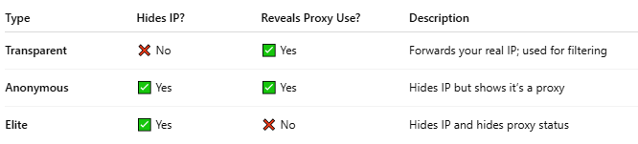
Type | Hides IP? | Reveals Proxy Use? | Description
Transparent | ❌ No | ✅ Yes | Forwards your real IP; used for filtering
Anonymous | ✅ Yes | ✅ Yes | Hides IP but shows it’s a proxy
Elite | ✅ Yes | ❌ No | Hides IP and hides proxy status

🧰 Use Cases:
# Source: Chatgpt (GPT‑5 Mini) at [1/14/2026]
- Bypass geo-restrictions
- Scrape websites without detection
- Avoid IP bans or rate limits
- Access censored content privately
- Use with bots or automation tools

🧱 How It Works:
# Source: Chatgpt (GPT‑5 Mini) at [1/14/2026]
- When your device sends a request, the Elite Proxy:
  - Strips all identifying headers (like X-Forwarded-For, Via, etc.)
  - Replaces your IP with its own
  - Disguises itself as a normal user connection
The target server sees a clean, untraceable request.

⚠️ Note:
# Source: Chatgpt (GPT‑5 Mini) at [1/14/2026]
- Elite proxies are often used in web scraping, SEO tools, and privacy-focused activities.
- Be cautious: using elite proxies to bypass restrictions or access illegal content can violate laws or terms of service.

